Test Plan for OTA Submitters

1. Go to /SitePages/DCAPXInfo.aspx and confirm you can access the site.
2. Have an associate also go to /SitePages/DCAPXInfo.aspx and confirm he/she can access the site.

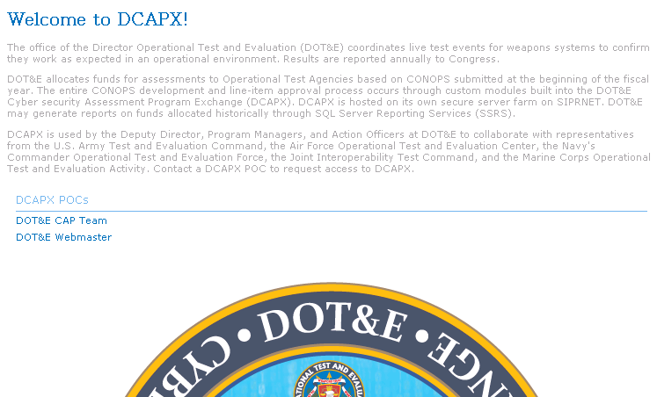

1. Click on the DOT&E CAP Team link and ask to be added to the DCAPX Site (/sites/DCAPX) as the primary contact for an OTA (AFOTEC, ATEC, COTF, JITC, or MCOTEA). This will give you the ability to submit CONOPS and add your associate who will be able to read CONOPS developed on the site.
2. Go to /sites/DCAPX to confirm you have access to DCAPX’s members-only section.  
   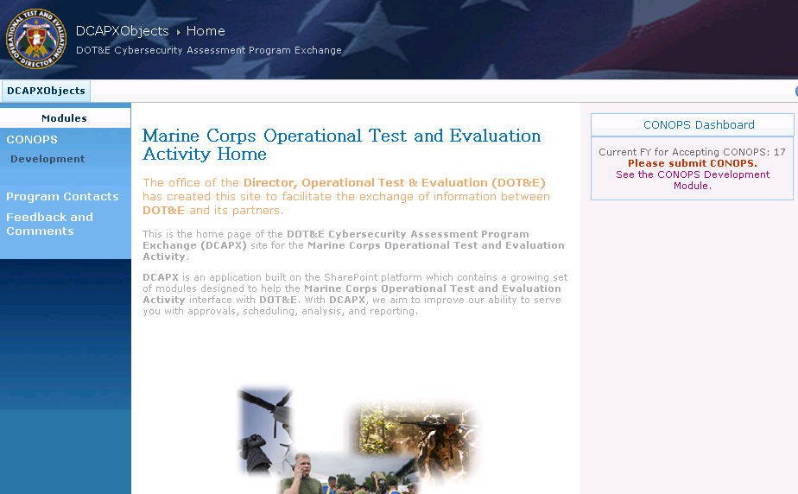
3. Click the Program Contacts link in the left menu and click Add new item in the dialog. Add your associate as a reader or CONOPS.   
   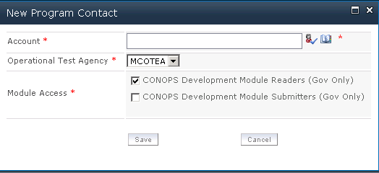
4. Under CONOPS in the left menu, click Development. Enter dummy data for worksheets 1-4 for the current FY for accepting CONOPS, the next FY, and the future FY. Only the current FY information will go through the approval process. The projections are considered estimates, and are for discussion only.   
   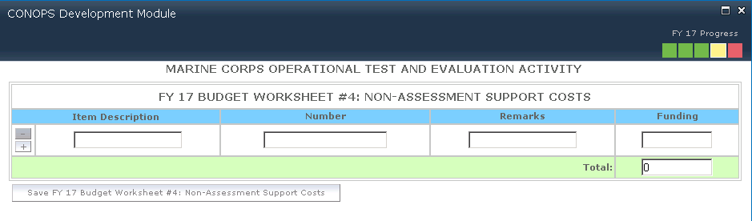
5. At some point you should save and click the x in the upper right corner of the dialog to simulate an interruption.   
   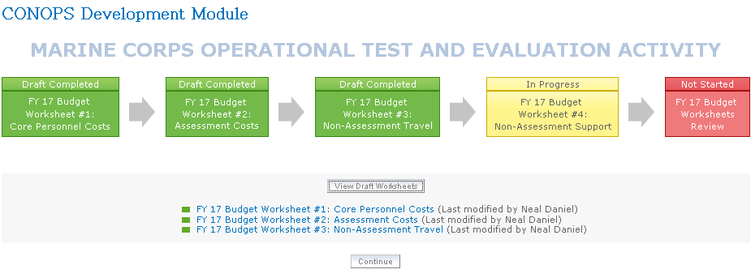
6. If available, click the View Draft Worksheets button and click on a link to view. Click the print icon in the upper right to confirm that you can print the view to share with colleagues.   
   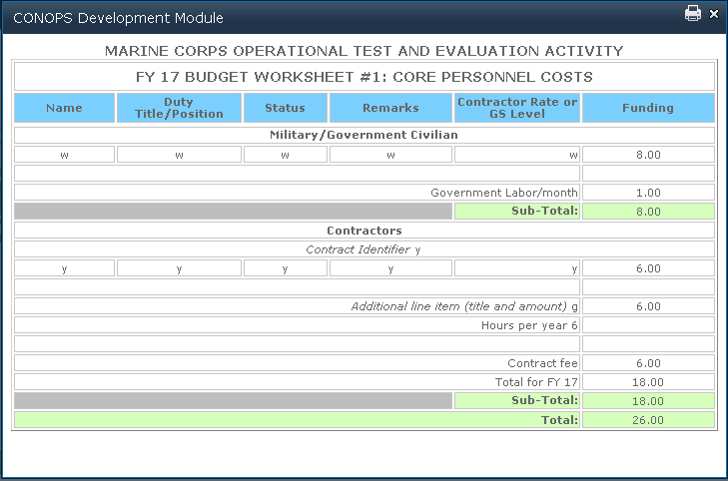
7. Back on the CONOPS Development Module page confirm you are able to resume working by clicking the Continue button. Review your work and click the OK button to complete your review after set of worksheets are drafted.   
   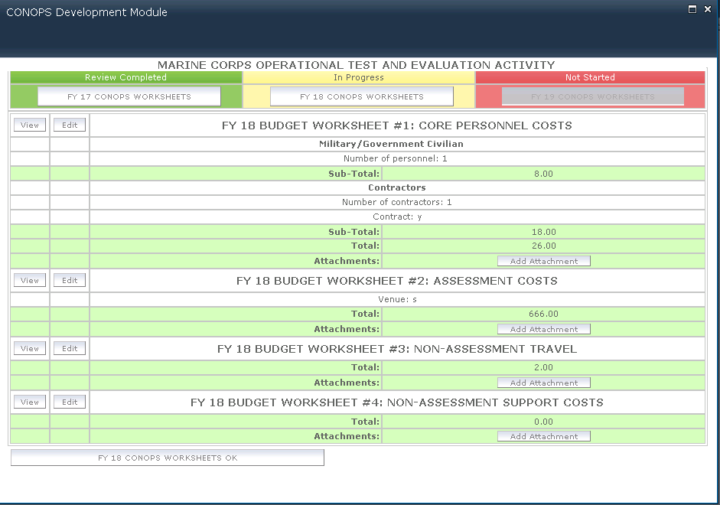
8. Click Add Attachment to add a dummy Approval Memo (PDF) from the Submit page.  
   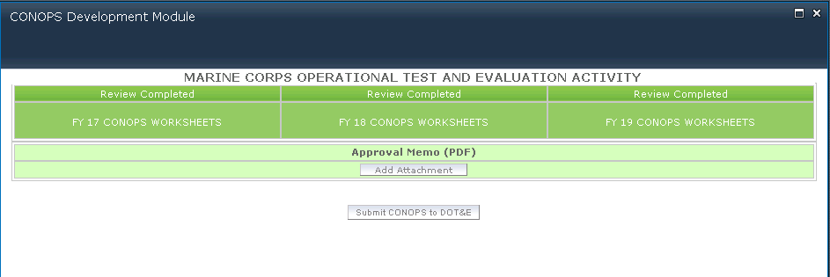
9. Click Submit CONOPS and view your submitted worksheets.

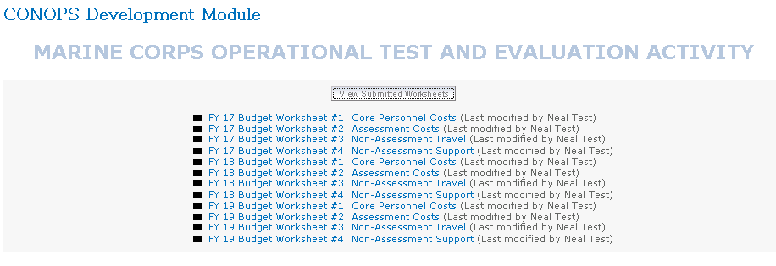

1. Your associate should be able to view the submitted CONOPS from the CONOPS Development Module page.
2. From /sites/DCAPX/SitePages/Home.aspx you should now see the CONOPS Dashboard in the upper right has changed to indicate that your submissions are being reviewed.   
   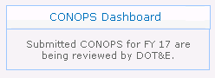
3. While we wait, click Feedback and Comments in the left menu and provide some feedback.   
   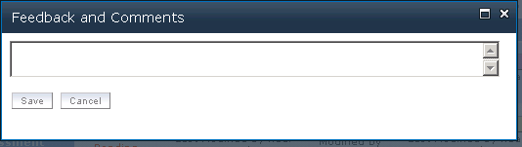
4. Click the CONOPS link in the left menu and review the CONOPS Milestones graphic. Click DCAPX to restore the navigation.  
   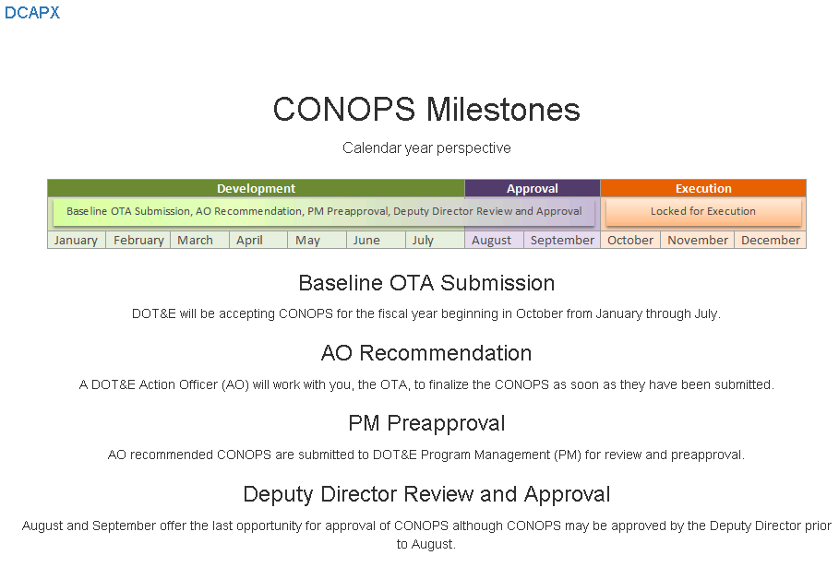
5. Follow the approval process progress from the CONOPS Dashboard in the upper right column.   
   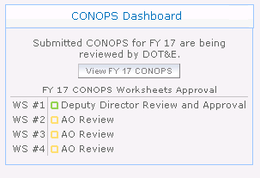
6. Click the View CONOPS button to view/print a consolidated view of all approved worksheets.   
   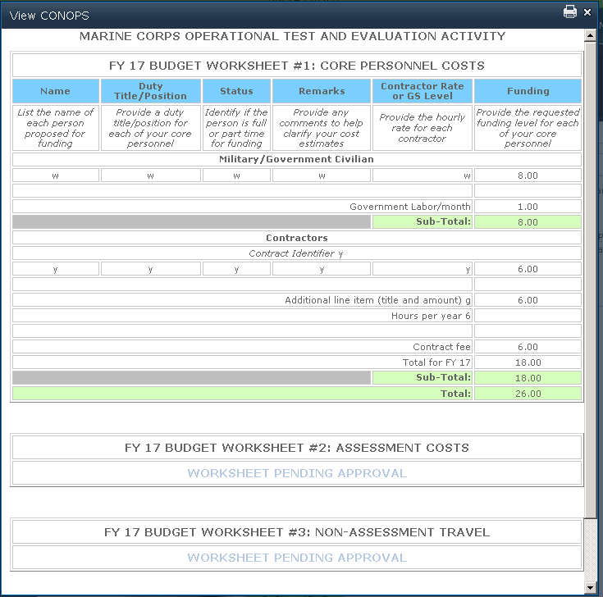
7. Once all worksheets have been approved you should see the CONOPS Dashboard with just the View CONOPS button. Click this to view a consolidated printable view of all approved worksheets for the current FY for accepting CONOPS.   
   